PROMPT: Evaluate the extent to which a lack of political compromise caused the Civil war in the period from 1850-1861.

DOCUMENT 1
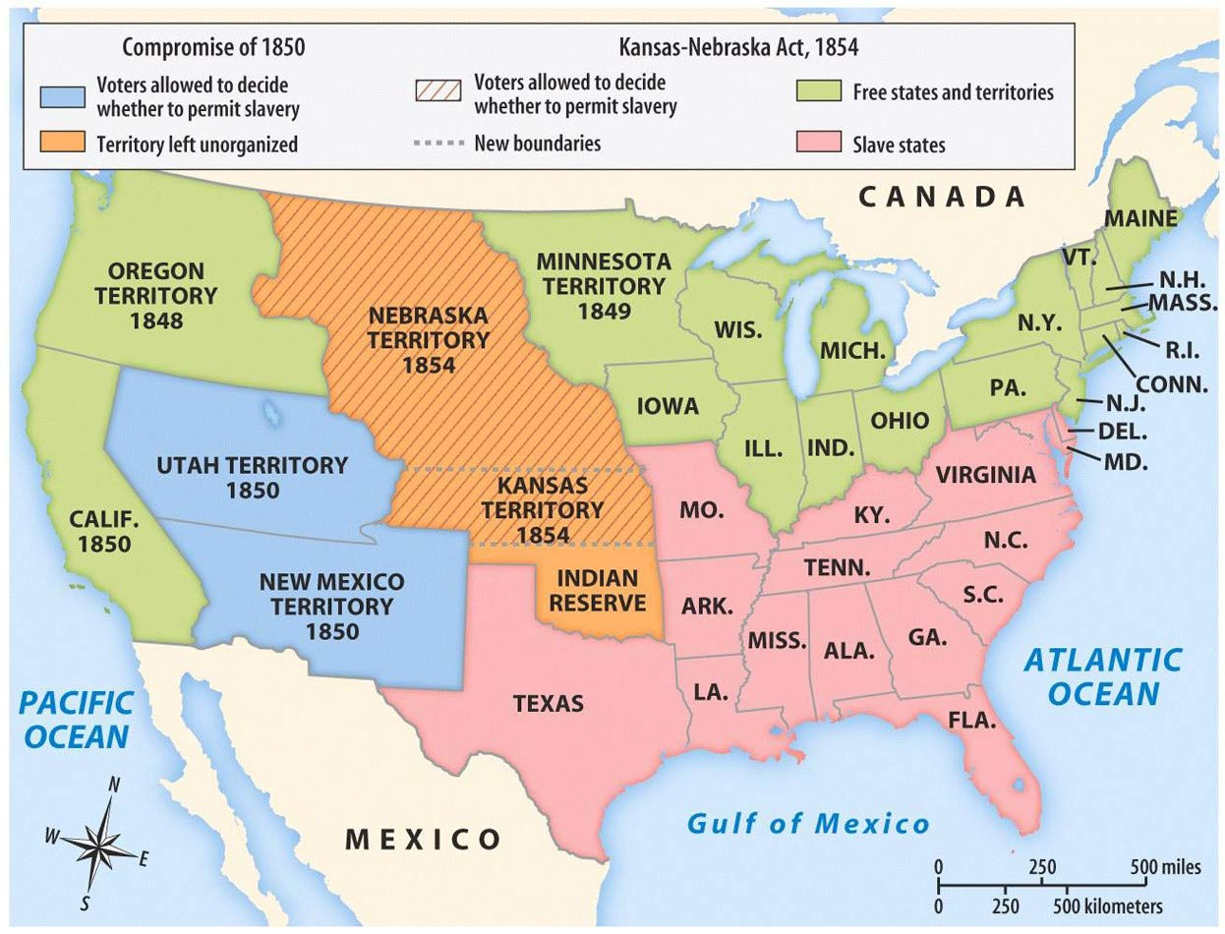
(maps do not have audiences, or POV’s, or purposes…it’s just a map)

DOCUMENT 2
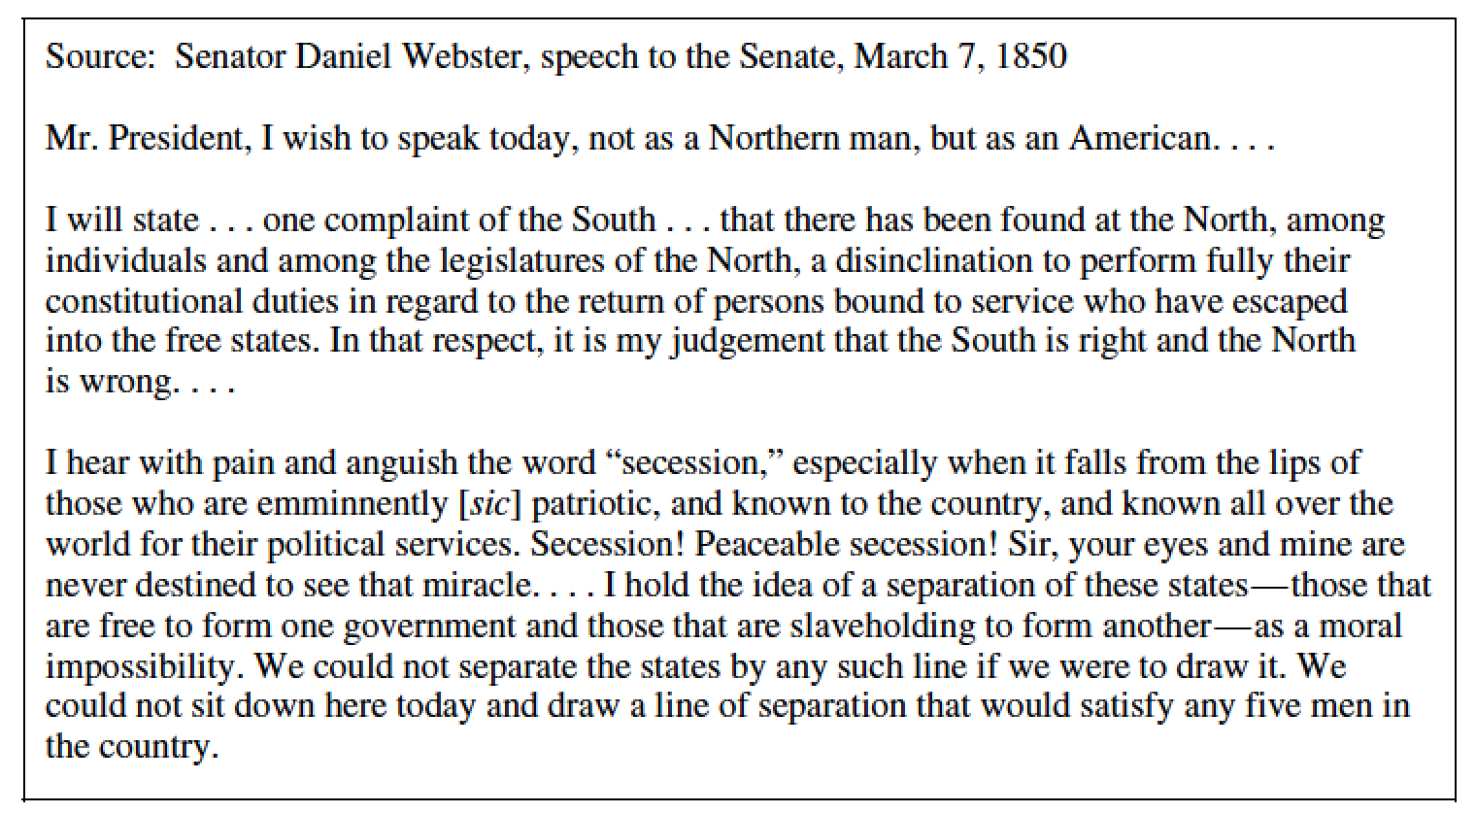

DOCUMENT 3
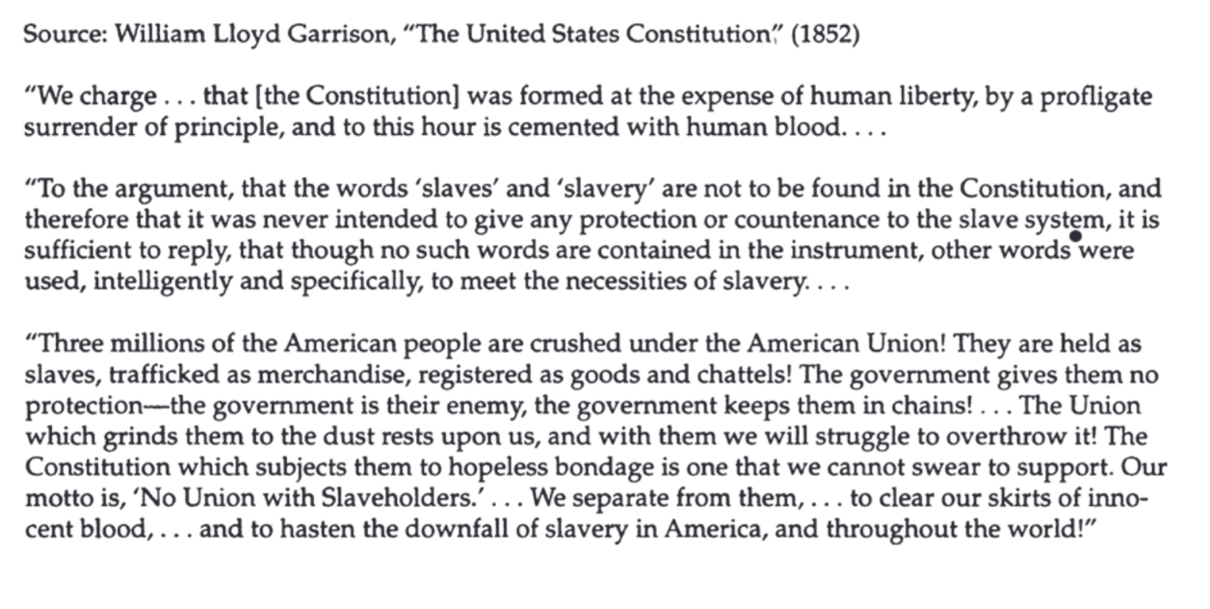
Document 4
“Southern Chivalry - Argument Versus Club’s”; cartoon by John L. Magee, 1856. Brooks/Sumner Affair
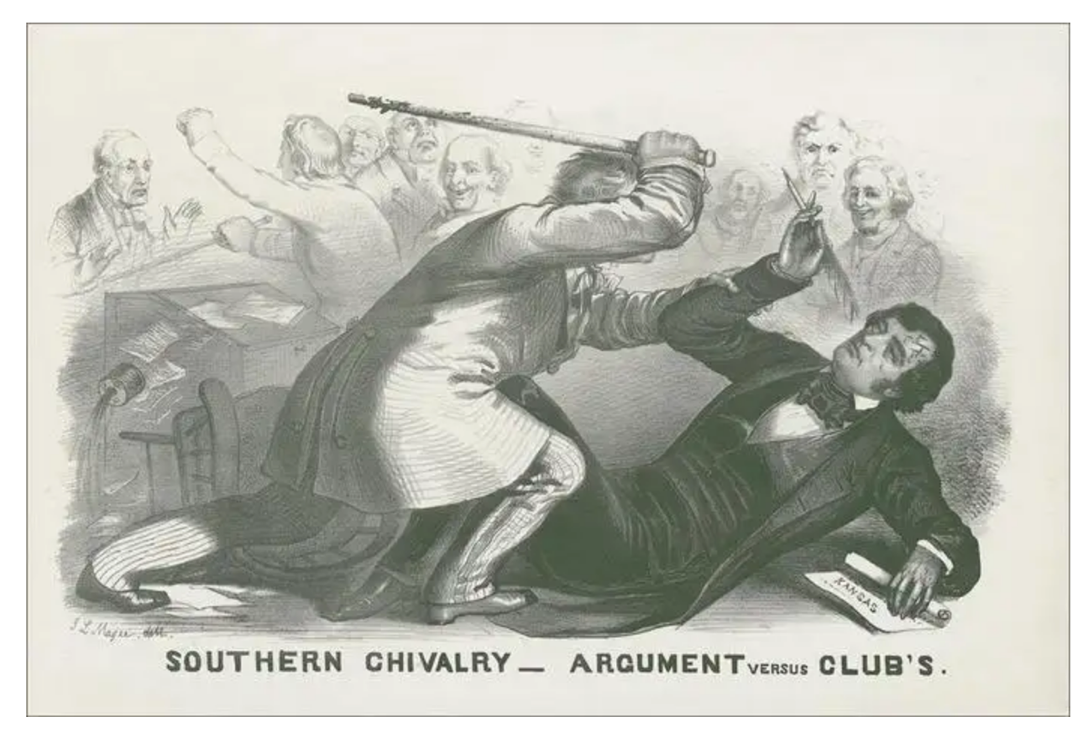
DOCUMENT 5
