APUSH SUMMER ASSIGNMENT: 2020-2021
If you are enrolled in AP US History for the 2020-2021 school year you are asked to complete the summer assignment. The details of the assignment are listed below. The parts that will be collected are attached.
- There are several purposes for a summer assignment:
  - AP US History is a survey course explores topics in US History from the 15th to 21st century. In order to ensure that all material is covered it is imperative that students get a head start.
  - Incoming juniors are often not used to the content or the rigorous requirements. This assignment provides students with an opportunity to become acclimated to the expectations of the course.
  - You are teaching yourself the material for Units 1 & 2 (1491-1754)
    - One MAJOR aspect to learning at a college level is HOW TO best comprehend the material. This is an EARLY opportunity to figure out how YOU learn best.
  - This should be a review of material from the 8th grade, but at a more intense and intimate level
  - You will be assessed on this material the first or second week of school

Please be diligent and do not wait until the last minute to complete this assignment.
Summer Assignment Assessment will take place the first or second week of school

Assignments:
- Purchase (OR WAIT UNTIL DISTRIBUTION OF TEXTBOOKS FOR THE SCHOOL TO PROVIDE ONE) AMSCO and complete the outlines for the first three chapters
- Purchase the AMSCO US History text using the link provided. If you choose to purchase it through another avenue, i.e. Amazon or Barnes and Noble please ensure that it is the latest version of the text.
- Google search – AMSCO US History
  - https://www.amscopub.com/social-studies/advanced-placement/united-states-history-ap-exam.html
- You must complete the outlines by printing out the outlines and writing directly on them.
- This will be collected and counted for a grade

- KHAN ACADEMY LEARNING GUIDE MODULES
  - Khan academy is an online non-profit education provider. They have aligned their modules (videos and summaries) with the AP US History curriculum. Watching these videos and reinforcing with reading the topic summaries is basically supplementing a textbook.
  - No purchase necessary, just use the website
  - This will be collected and counted for a grade

- APUSHReview.com Videos and Outlines
- Watch the videos for Key Concepts 1.1-2.3 in addition to The Encomienda System, the Pueblo Revolt, and The Enlightenment
- Fill out the notes as you watch the videos – this will NOT be collected but is important in understanding the main concepts.
- Key Concepts 1.1-1.3; Encomienda System
  - http://www.apushreview.com/new-ap-curriculum/period-1-1491-1607/
- Key Concepts 2.1-2.3; The Enlightenment
  - http://www.apushreview.com/new-ap-curriculum/period-2-1607-1754/
- Watch 3 videos on The Enlightenment and 1st and 2nd Great Awakening, taking notes for upcoming Quiz
  - https://www.youtube.com/watch?v=7kdz1kwejAk
  - https://www.youtube.com/watch?v=KqvBUsrLzrI
  - https://www.youtube.com/watch?v=P-Kjec4dF04
- Crash Course US History Videos
- John Green has become an invaluable resource to the virtual learning process. Green has created short videos (10-15 minutes) that perfectly hit all of the major themes, events, and individuals throughout US History.
- Please view videos 1-4 and answer the recommended guide questions provided – this will NOT be collected
  - https://www.youtube.com/playlist?list=PL8dPuuaLjXtMwmepBjTSG593eG7ObzO7s
  - It is suggested to watch the videos AFTER you have completed the reading assignments or as a study took for the exam, as this is more of a review.
UNIT I (1491-1607) AMSCO Ch. 1 Student Outline– A New World of Many Cultures

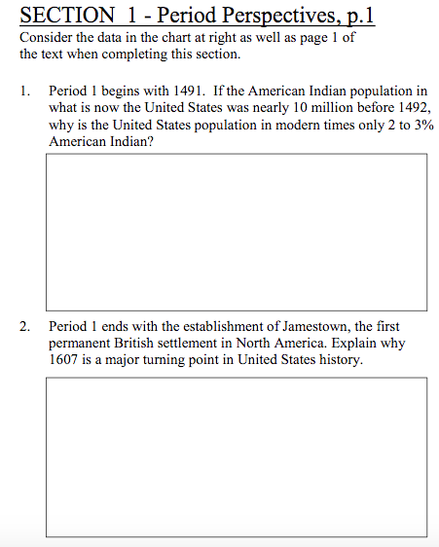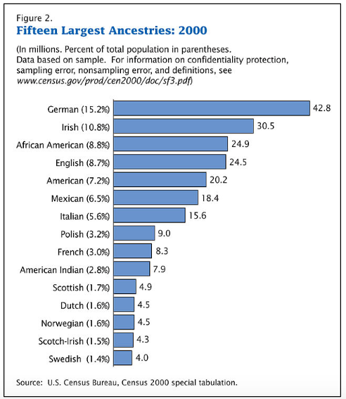

- Describe the similarities and differences between the three highly developed native populations in the time before Columbus –
  - Mayas:

  - Aztecs:

  - Incas:

- Describe how each of the following adapted to their environments and how that contributed to their varying lifestyles –
  - Southwest settlements:

  - Northwest settlements:

  - Great Plains:

  - Midwest Settlements:

  - Northeast Settlements:

  - Atlantic Seaboard settlements:

- Explain how each of the following impacted Europe’s move toward exploration –
  - Major improvements in technology:

  - Protestant Reformation:

  - Economic incentive:

  - Competition among nation-states:

- What was Christopher Columbus’ goal? Explain how his discovery was a success and a failure?

- Describe what the Columbus Exchange was –

- Explain the impact of the Columbus Exchange on BOTH –
  - Old World:

  - New World:

- Explain the impact of Spanish exploration and conquest in the context of –
  - Image of conquistadores:

  - The Encomienda System:

- Identify early territorial claims (may be more than one location) of each of the following:
  - Spanish:

  - English:

  - French:

  - Dutch

  - Describe the similarities and differences between these land claims –

- Compare and contrast the treatment of Native Americans by each of the following groups –
  - Spanish:

    - Explain WHY the Spanish responded to Natives in this way –

  - English:

    - Explain WHY the English responded to Natives in this way –

  - French:

    - Explain WHY the French responded to Natives in this way –

  - Explain how the Native American response to European policy would eventually lead to their ultimate subordination –

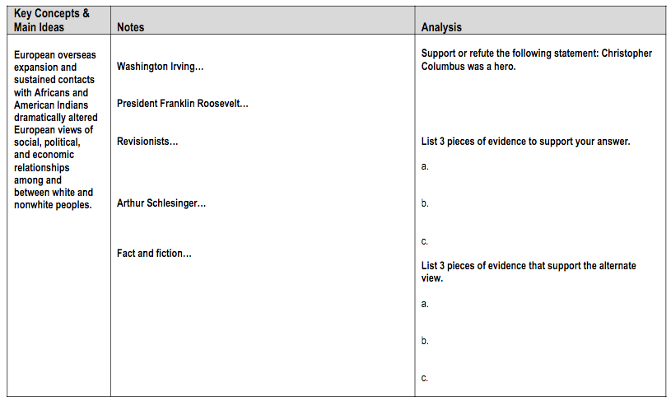

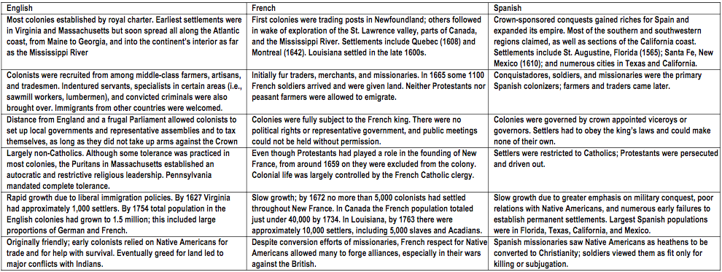

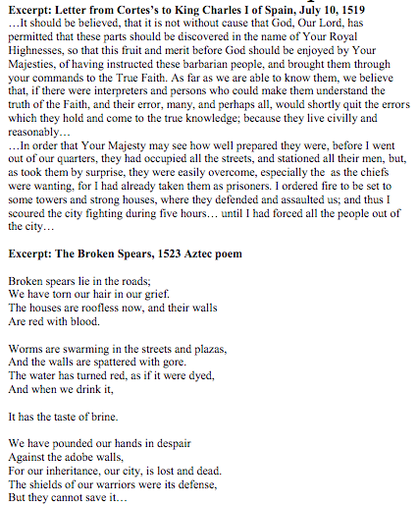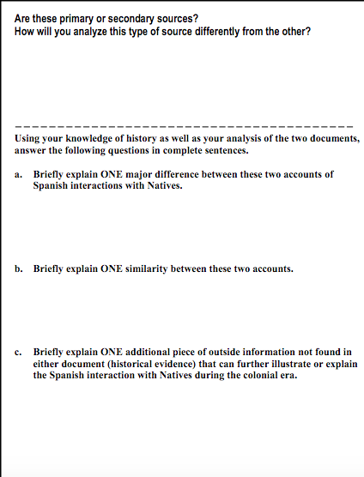

Answer the multiple-choice questions by writing the correct answer in the spaces below:

1.
2.
3.
4.
5.
6.
7.
8.
9.

Please answer Short Answer #4 in the spaces below:
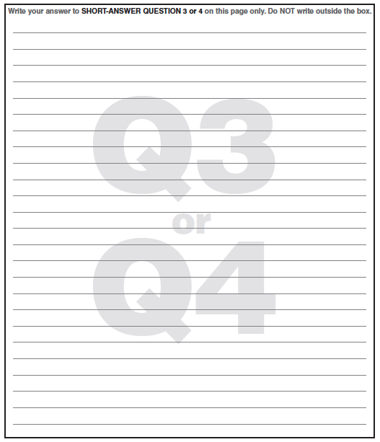
Document analysis
Document 1: Columbus Reports on his first voyage, 1493 | Summarize the excerpt (in your own words) - | Based on the excerpt, describe Columbus’ audience and the significance of his letter -
Document 2: Spain authorizes Coronado’s conquest in the Southwest, 1540 | Summarize the transcript (in your own words) - | Based on the transcript, describe on major PURPOSE for Spanish conquest -

UNIT II (1607-1754) AMSCO Ch. 2 Student Outline – The Thirteen Colonies and The British Empire
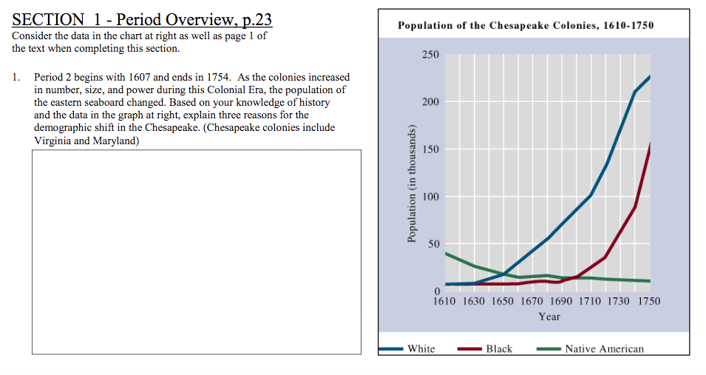
- Describe the DIFFERENCE between the types of charters granted by the English crown –

  - Explain WHY you think different charters even existed –

- Describe 3 reasons why the English were motivated to populate/colonize the America’s in the early 1600s –
  - Spanish Armada:

  - Increased opportunity:

  - Joint-Stock Company:

- Describe the differences and similarities of the early English settlements of Jamestown, Plymouth, and Massachusetts Bay in the following contexts –
  - Motives for settlement:

  - Charter status:

  - Adaption to environment:

  - Political institutions:

- Describe the irony of the Act of Toleration in Maryland –

- Describe why the southern colonies (Chesapeake region) needed more labor than the northern colonies (New England) –

- Explain each of the following labor systems –
  - Indentured Servants:

  - The Headright System:

  - Slavery:

- Describe the circumstances behind, the immediate impact, and the long-term impact of Bacon’s Rebellion –

- Describe how each of the following individuals or events contributed to the development of New England –
  - Roger Williams:

  - Anne Hutchinson:

  - Thomas Hooker:

  - Halfway Covenant:

  - New England Confederation:

  - King Philip’s War:
- Explain how the English Restoration led to the development of the following English colonies and describe each of them –
  - The Carolinas:

  - New York:

  - New Jersey:

  - Pennsylvania:

    - Describe difference between the Quakers in Pennsylvania and the Puritans in New England:

  - Georgia:

- Define mercantilism –

- Explain how the Acts of Trade and Navigation represent England moving toward mercantilist policies –

- Explain how the colonies reacted to the trade and navigation acts –

- Explain why slavery was increasingly important in the southern colonies –

- Describe triangular trade –

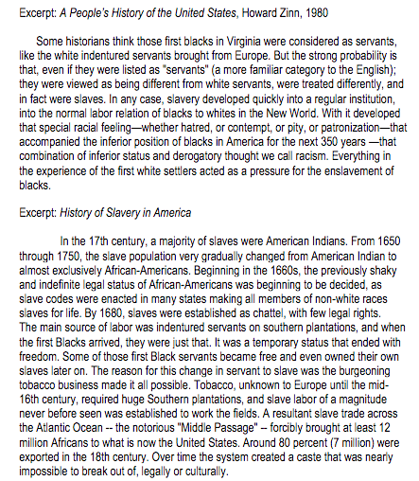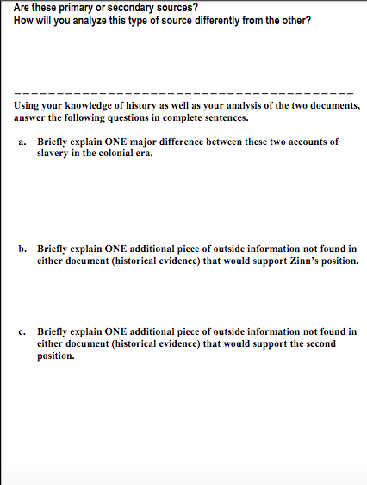

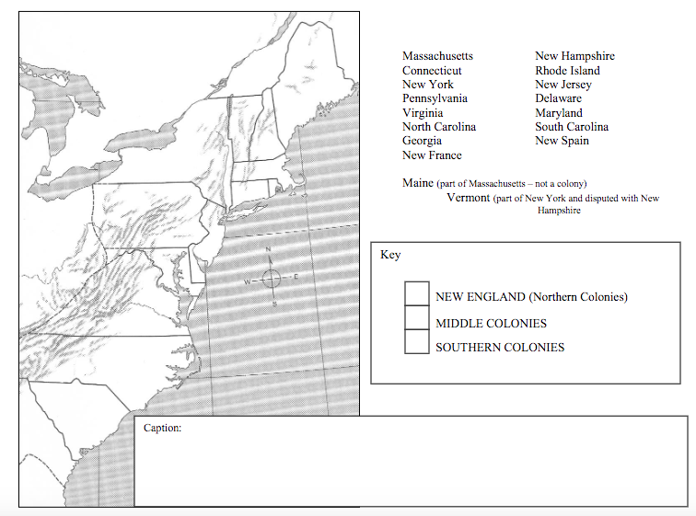

Answer the multiple-choice questions by writing the correct answer in the spaces below:
Please answer Short Answer #4 in the spaces below:
DOCUMENT ANALYSIS
Document 1: A Jamestown settler describes life in Virginia, 1622 | Summarize the transcript (in your own words) - | Contextualize what life was like for early settlers of Jamestown, based on the transcript -
Document 2: James Winthrop describes life in Boston, 1634 | Summarize the excerpt (in your own words) - | Based on documents 1 and 2, compare Boston to Virginia -

UNIT II (1607-1754) Ch. 3 Student Outline – COLONIAL SOCIETY IN THE 18TH CENTURY
- Describe the varying immigrant groups that populated colonial America by evaluating WHY they settled, WHERE they settled and how their own cultural background effected their settlement:
  - English –

  - Germans –

  - Scotch-Irish –

  - Other Europeans –

  - Africans –

- Describe the significance of colonial America establishing self-government (make sure you know exactly what that is for EACH colony) and religious toleration:

- Describe the differences in the economies and religion of each of the following:
  - New England –

  - Middle Colonies –

  - Southern Colonies –

- Explain the main cause of The Great Awakening:

- Describe how Jonathan Edwards and George Whitefield described God:

  - Explain how their beliefs/teachings impacts American colonists both religiously and politically?

- Describe how education fluctuated throughout the colonies AND describe the impact of The Great Awakening on higher education.

- Describe the circumstances behind the John Peter Zenger case (if you don’t know what libel is than look it up!)

  - Describe the significance of the case on colonial history:

- Describe the Enlightenment:

- Describe the impact of John Locke on both Enlightenment thought as well as colonial rights:

- Explain how American character differed from British character:

- Describe colonial democracy:

  - Explain how it was both restrictive and opportunistic:

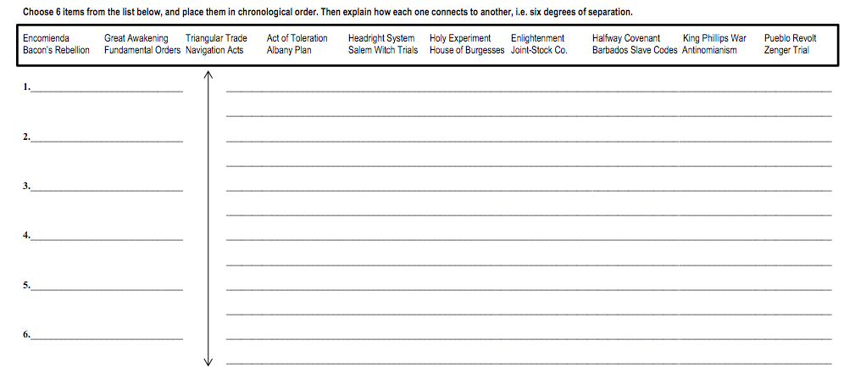

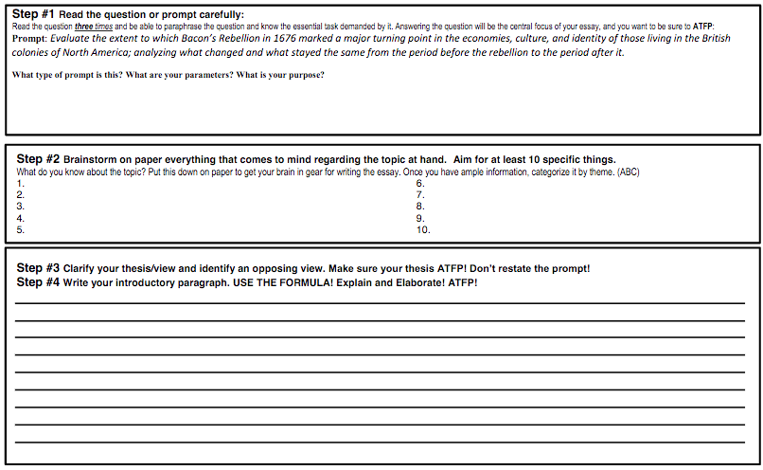
Answer the Multiple Choice below:

Please answer Short Answer #1 in the spaces below:
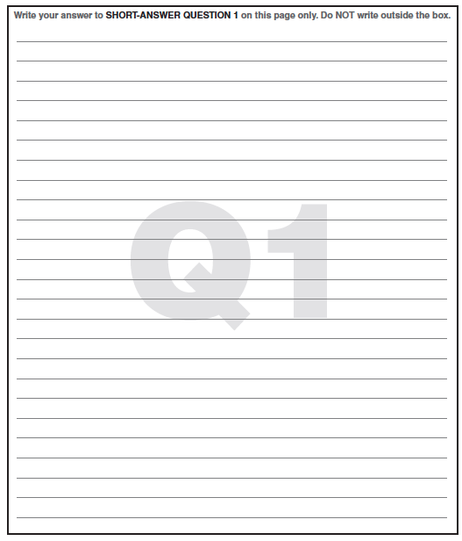
DOCUMENT ANALYSIS
Document 1: Arguments for educating women (1735) | Summarize the excerpt (in your own words) - | Describe the author’s point of view (bias) about educating women -
Document 2: Olaudah Equiano | Summarize the excerpt (in your own words) - | Describe the author’s point of view (bias) about the middle passage -

KHAN ACADEMY - LEARNING GUIDE
PERIOD 1: 1491-1607
(AMSCO) Chapter 1: A New World of Many Cultures
This ALL needs to be completed on a separate sheet of paper, HANDWRITTEN
Label each section as your work
No credit will be given for partial work (all or nothing)
To ensure you complete all tasks, PRINT this document and check off the boxes as you go ()

Visit the following page - https://www.khanacademy.org/humanities/ap-us-history/period-1#apush-how-to-think-like-a-historian

PERIOD 1: 1491-1607
- WATCH
  - Native Societies before contact
  - Outline key points from the video
- READ
  - Native Indian culture of the Northeast
- Outline key points from the reading
- Answer questions, “What do you think?” – in complete sentences
- READ
  - Native Indian culture of the Southeast
- Outline key points from the reading
- Answer questions, “What do you think?” – in complete sentences
- READ
  - Pre-colonization European society
  - Outline key points from reading
  - Answer questions, “What do you think?” – in complete sentences
- READ
  - African societies and the beginning of the Atlantic slave trade
  - Outline key points from the reading
  - Answer questions, “What do you think?” – in complete sentences
- READ
  - Motivation for European conquest of the New World
  - Outline key points from the reading
  - Answer questions, “What do you think?” – in complete sentences
- WATCH
  - Origins of European exploration in the Americas
- Outline key points from the video
- WATCH
  - Christopher Columbus & Consequences of Columbus’s voyage of the Tainos and Europe
- Outline key points from the video
- WATCH
  - The Columbian Exchange
- Outline key points from the video
- READ
  - The Columbian Exchange
  - Outline key points from reading
  - Answer questions, “What do you think?” – in complete sentences
- READ
  - Environmental and health effects of European contact with the New World
  - Outline key points from reading
  - Answer questions, “What do you think?” – in complete sentences
- LESSON SUMMARY
  - Answer “Review questions” in complete sentences
- WATCH
- Spanish colonization
  - Outline key points from the video
- READ
- The Spanish conquistadores and colonial empire
  - Outline key points from reading
  - Answer questions, “What do you think?” – in complete sentences
- READ
- Pueblo uprising of 1680
  - Outline key points from reading
  - Answer questions, “What do you think?” – in complete sentences
- WATCH
- Comparing European and Native American cultures
  - Outline key points from the video
- LESSON SUMMARY
  - Answer “Review questions” in complete sentences

KHAN ACADEMY - LEARNING GUIDE
PERIOD 2: 1607-1754
(AMSCO) Chapter 2: The Thirteen Colonies and the British Empire
Chapter 3: Colonial Society in the 18th Century
This ALL needs to be completed on a separate sheet of paper, HANDWRITTEN
Label each section as your work
No credit will be given for partial work (all or nothing)
To ensure you complete all tasks, PRINT this document and check off the boxes as you go ()

Visit the following page - https://www.khanacademy.org/humanities/ap-us-history/period-2

PERIOD 2: 1607-1754
- WATCH
  - French and Dutch colonization
  - Outline key points from the video
- READ
  - French and Dutch exploration in the New World
- Outline key points from the reading
- Answer questions, “What do you think?” – in complete sentences
- WATCH
  - English in the Age of Exploration
  - Outline key points from the video
- WATCH
  - Motivation for English colonization
  - Outline key points from the video
- WATCH
  - Early English settlements - Jamestown
  - Outline key points from the video
- WATCH
  - Jamestown – the impact of tobacco
  - Outline key points from the video
- WATCH
  - Jamestown – life and labor in the Chesapeake
  - Outline key points from the video
- WATCH
  - Jamestown – Bacon’s Rebellion
  - Outline key points from the video
- WATCH
  - The West Indies and the Southern colonies
- Outline key points from the video
- LESSON SUMMARY
  - Answer “Review questions” in complete sentences
- WATCH
  - Slavery in the British colonies
- Outline key points from the video
- READ
  - Slavery in the British colonies
  - Outline key points from reading
  - Answer questions, “What do you think?” – in complete sentences
- LESSON SUMMARY
  - Answer “Review questions” in complete sentences
- WATCH
  - Society and religion in the New England colonies
  - Outline key points from video
- WATCH
  - Politics and native relations in the New England colonies
  - Outline key points from video
- READ
  - Puritan New England: Plymouth
  - Outline key points from reading
  - Answer questions, “What do you think?” – in complete sentences
- READ
  - Puritan New England: Massachusetts Bay
  - Outline key points from reading
  - Answer questions, “What do you think?” – in complete sentences
- WATCH
- The Middle Colonies
  - Outline key points from the video
- LESSON SUMMARY
  - Answer “Review questions” in complete sentences
- READ
- The Navigation Acts
  - Outline key points from reading
  - Answer questions, “What do you think?” – in complete sentences
- READ
- The Enlightenment
  - Outline key points from reading
  - Answer questions, “What do you think?” – in complete sentences
- READ
- The Great Awakening
  - Outline key points from reading
  - Answer questions, “What do you think?” – in complete sentences
- WATCH
- Developing an American colonial identity
  - Outline key points from the video

